**How to install Cloudera**

1. Go to <http://www.cloudera.com/downloads/quickstart_vms/5-8.html>
2. Select QUICKSTART DOWNLOADS FOR CDH 5.8; select VMWare for ‘Select a platform’

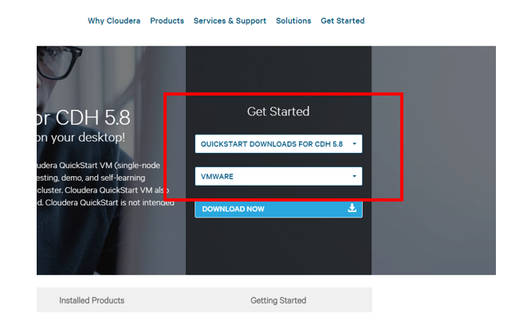

1. Click on Download Now. Fill out the registration form. Change the personal information to yours. Then click CONTINUE. The downloading page will pop out (It is a zip file).



1. Unzip the file you just downloaded.
2. Open cloudera-quickstart-vm-5.8.0-0-vmware.vmx by using VMPlayer